**EXPERIMENT NO 5**

~ Trushant Rathod

COMPS 18

**Aim:** To implement Circular Queue ADT using array

**Objective:**

Circular Queue offer a quick and clean way to store FIFIO data with maximum size

**Theory:** A Circular queue is a linear data structure where the first index comes right

after the last index assuming indices are attached in a circular manner.

**Algorithm:**

1. Create an array 'items' of size 'SIZE' and initialize 'front' and 'rear' to -1.

2. Define a function isFull():

- If ((front == rear + 1) or (front == 0 and rear == SIZE - 1)), return true (1).

- Otherwise, return false (0).

3. Define a function isEmpty():

- If 'front' is -1, return true (1).

- Otherwise, return false (0).

4. Define a function enQueue(element):

- If isFull() returns true:

- Print "Queue is full."

- Else:

- If 'front' is -1, set 'front' to 0.

- Increment 'rear' (rear = (rear + 1) % SIZE).

- Store 'element' in 'items[rear]'.

- Print "Inserted -> element".

5. Define a function deQueue():

- If isEmpty() returns true:

- Print "Queue is empty."

- Return -1 to indicate an error.

- Else:

- Store 'element' as 'items[front]'.

- If 'front' equals 'rear', indicating there's only one element:

- Set 'front' and 'rear' back to -1 to empty the queue.

- Otherwise, increment 'front' (front = (front + 1) % SIZE).

- Print "Deleted element -> element".

- Return 'element'.

6. Define a function display():

- If isEmpty() returns true:

- Print "Empty Queue."

- Else:

- Print "Front -> front".

- Print "Items -> ".

- Loop 'i' from 'front' to 'rear':

- Print "items[i] ".

- Print "Rear -> rear".

7. In the main program:

- Perform operations like enQueue, deQueue, and display to demonstrate the circular queue.

8. End of the program.

**Code:**

#include <stdio.h>

#include<stdlib.h>

#define SIZE 5

int items[SIZE];

int front = -1, rear = -1;

int isFull() {

if ((front == rear + 1) || (front == 0 && rear == SIZE - 1))

return 1;

return 0;

}

int isEmpty() {

if (front == -1)

return 1;

return 0;

}

void enQueue(int element)

{

if (isFull())

printf("\n Queue is full!! \n");

else {

if (front == -1) front = 0;

rear = (rear + 1) % SIZE;

items[rear] = element;

printf("\n Inserted -> %d", element);

}

}

int deQueue()

{

int element;

if (isEmpty())

{

printf("\n Queue is empty !! \n");

return (-1);

} else {

element = items[front];

if (front == rear) {

front = -1;

rear = -1;

}else {

front = (front + 1) % SIZE;

}

printf("\n Deleted element -&gt; %d \n", element);

return (element);

}

}

void display() {

int i;

if (isEmpty())

printf(" \n Empty Queue\n");

else {

printf("\n Front -> %d ", front);

printf("\n Items -> %d ");

for (i = front; i != rear; i = (i + 1) % SIZE) {

printf("%d ", items[i]);

}

printf("%d &quot", items[i]);

printf("\n Rear -> %d \n ", rear);

}

}

int main() {

deQueue();

enQueue(1);

enQueue(2);

enQueue(3);

enQueue(4);

enQueue(5);

enQueue(6);

display();

deQueue();

display();

enQueue(7);

display();

enQueue(8);

return 0;

}

**Output:**

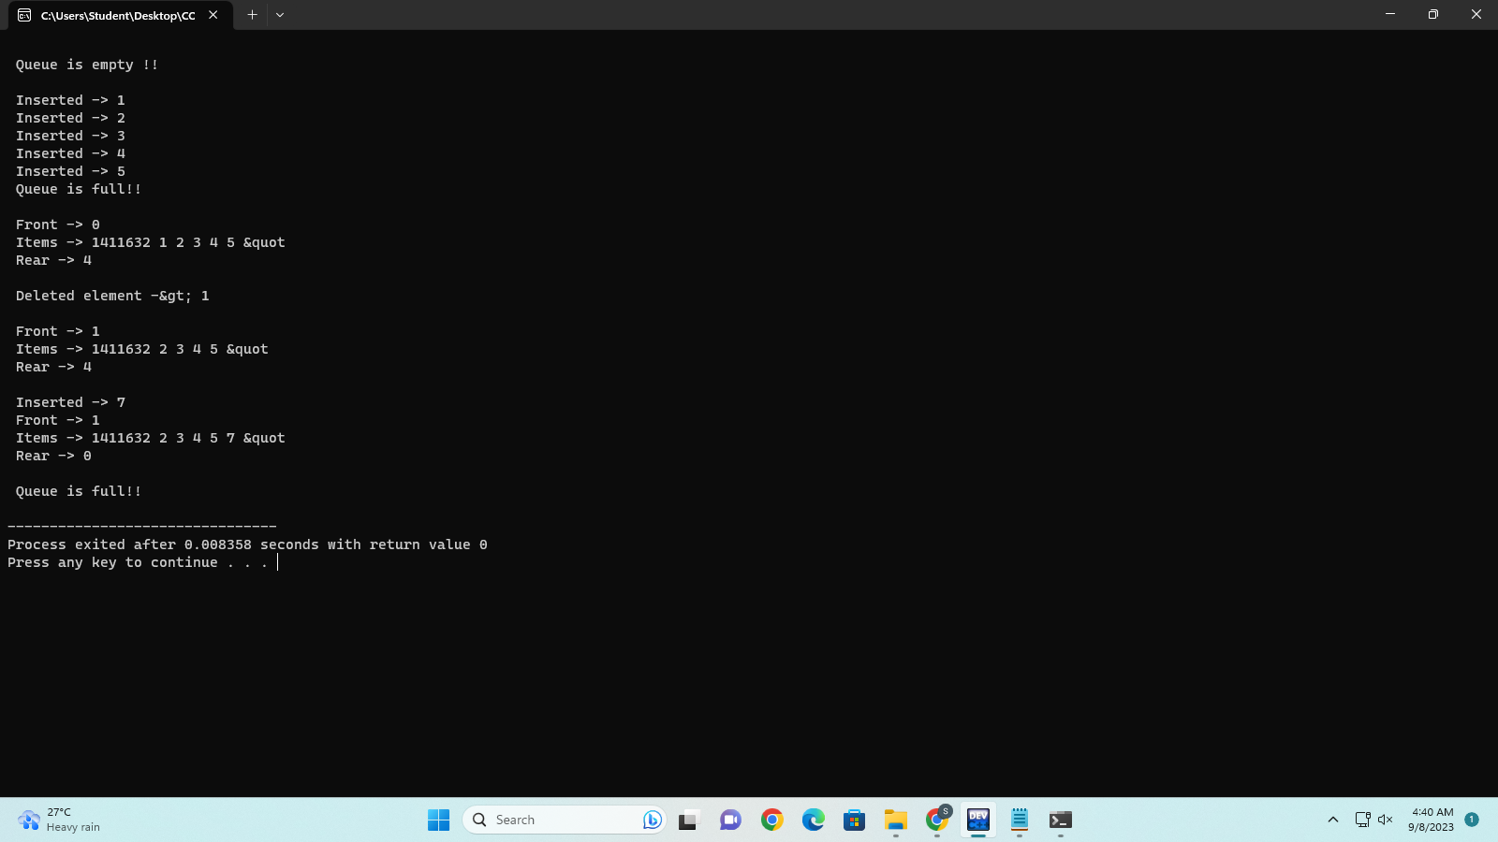

**Conclusion:**

he circular queue provides efficient enqueue and dequeue operations with time complexity. However, it has a fixed size, and if the queue becomes full, additional elements cannot be added without removing existing ones.